**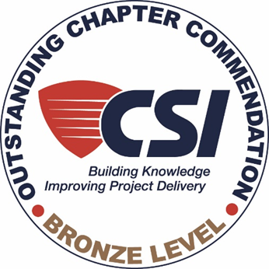

Todd Johnson

Margaret Fisher

Annual Sponsors :

**Thursday, February 2, 2023**

Join 6:00 pm for 6:30 pm start

Register to get link for meeting

* Learn what Information a Detailer need
* Hear the History of Detailing from Sketches to 3-D models
* See Why Fabrication drawings are essential
* How is Fabrication done
* See examples of complex steel construction
* Learn the 5 most important questions to ask
* Approved for 1 AIA LU HSW credit

**Next Tacoma Meeting:**

**ZOOM**

**March 2, 2023 6:00 pm**

**“Accidents & Site Safety”** by Don Coovert of Korsmo Construction

**Next Tacoma Meeting:**

**ZOOM**

**April 6, 2023 6:00 pm**

**“Building in Belize”** by Doug Dickinson, CSI Retired

**Next Tacoma Meeting:**

**In Person Joint Meeting w/ AIA SWW**

**April 19, 2023 6:00 pm**

**“TBD”** by

**Reservations:**

Guests are always Welcome

Need to register to obtain Link for Meeting

**No Cost**

***Meeting Schedule:***

*6:00 - 6:30 pm “CSI Squares” Ask and Learn*

*6:30 pm Presentation*

*7:30 pm Questions & Answers/Closing*

***Register online by Tuesday, January 31, 2023*** *at*  <http://csimtrainier.org/events>

***Tacoma Meeting***

**ViaZOOM**

**Speakers: Patricia Tremaine & Juan Hernandez**

**of Superior Steel**

**The Art of Steel Fabrication or**

**How do They bend the Pipe**

**Thursday, May 2, 2019**

Being registered for 1.0 continuing education credit

* Why is the Building Code always being changed?
* Significant Changes in the IBC/ IRC
* New additions to Construction Type IV
* Code Review and Acceptance Process
* How can Architects and others participate

**Who are we? Everyone!!**

**(in Construction)**

**What do we do? Everything!!**

**(in Construction)**

**Don’t call us Specwriters. We are so much more than Specifications!!**

***Different Roles***

***Common Ground***

***Better Builds***

**Mt. Rainier Chapter**

www.csimtrainier.org

**Recipient of 2014 Institute Chapter Cup Award**

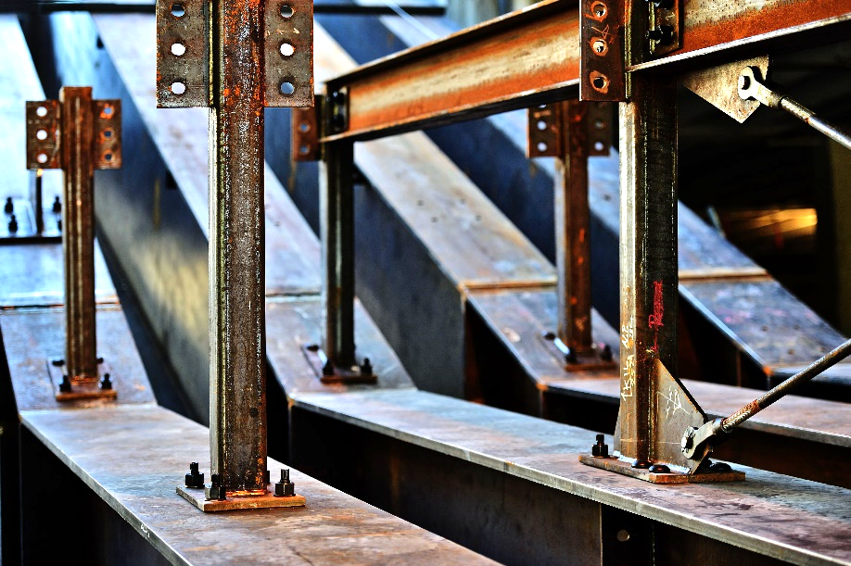

***2010, 2014, 2015, 2016, 2017, 2020, 2021, 2022***

Joan Schaefer

Nora Vivarelli

William Clark & Associates